National University of Computer and Emerging Sciences



Laboratory Manuals

for

Database Systems Lab
(CL -2005)

Course Instructor | Ms. Aleena Ahmad
Lab Instructor | Muhammad Kamran
Lab TA | Abdullah Naeem
Section | BCS-4F
Semester | Spring 2025

Department of Computer Science
FAST-NU, Lahore, Pakistan
Lab Manual 14

SQL
SQL tutorial gives unique learning on Structured Query Language and it helps to make practice on SQL commands which provides immediate results. SQL is a language of database, it includes database creation, deletion, fetching rows and modifying rows etc. SQL is an ANSI (American National Standards Institute) standard, but there are many different versions of the SQL language.
Why SQL?
- Allows users to access data in relational database management systems.
- Allows users to describe the data.
- Allows users to define the data in the database and manipulate that data.
- Allows embedding within other languages using SQL modules, libraries & pre-compilers.
- Allows users to create and drop databases and tables.
- Allows users to create views, stored procedure, functions in a database.
- Allows users to set permissions on tables, procedures and views
SQL Process
When you are executing an SQL command for any RDBMS, the system determines the best way to carry out your request and SQL engine figures out how to interpret the task.
There are various components included in the process. These components are Query Dispatcher, Optimization Engines, Classic Query Engine and SQL Query Engine, etc. Classic query engine handles all non-SQL queries, but SQL query engine won't handle logical files.
Following is a simple diagram showing SQL Architecture:
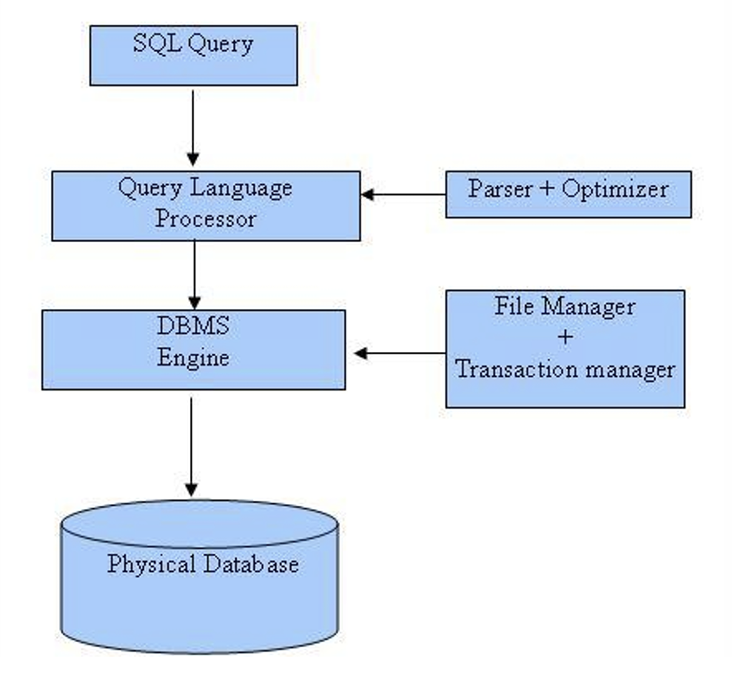

Check the following Trigger and understand concepts used in the following trigger
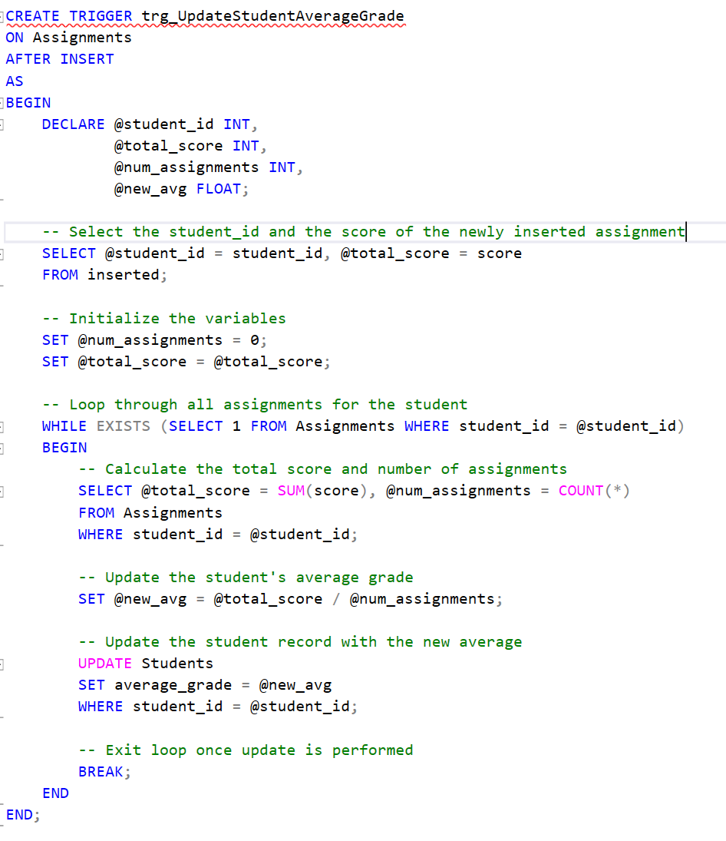

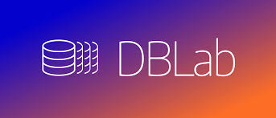
Happy learning and querying!

Download sql file provided with this manual. Run that file and a schema with following details will be created:
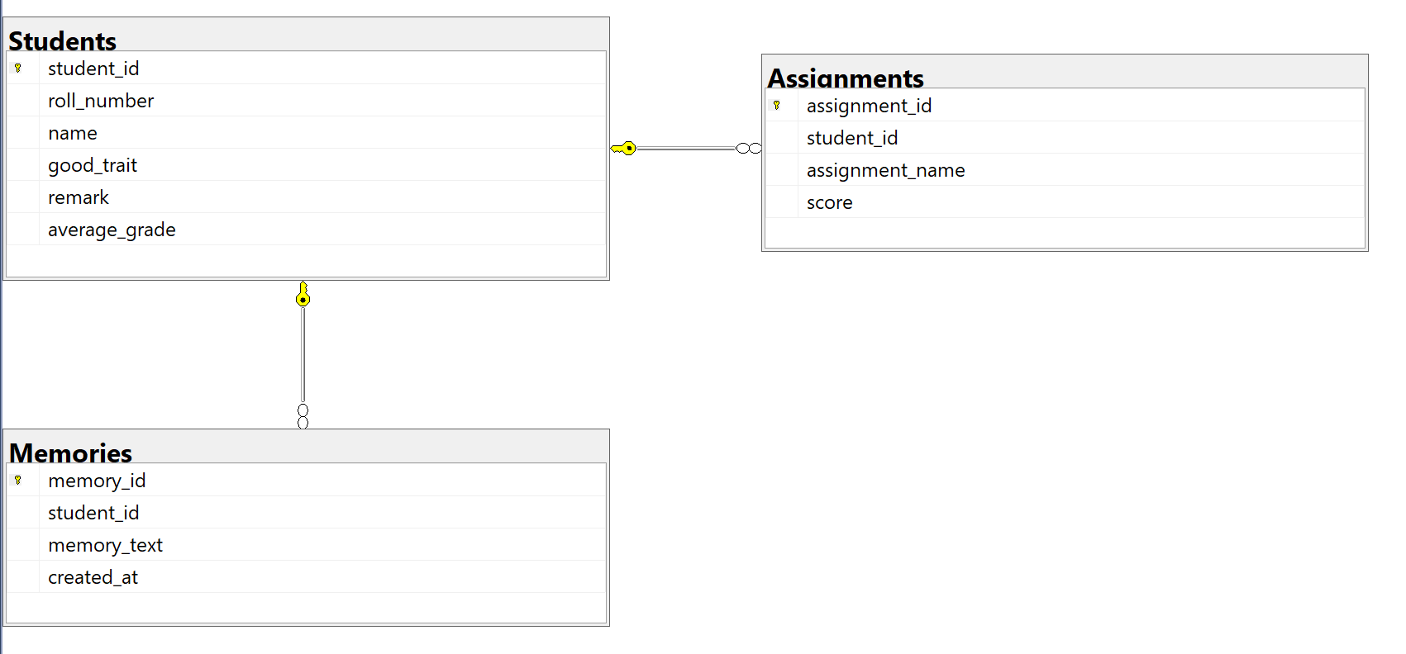


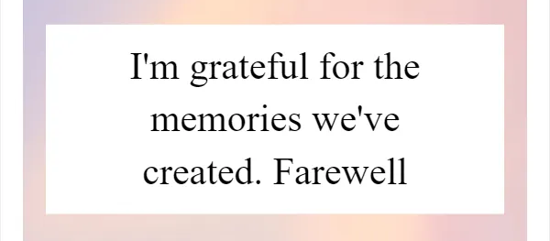
In Lab Exercises

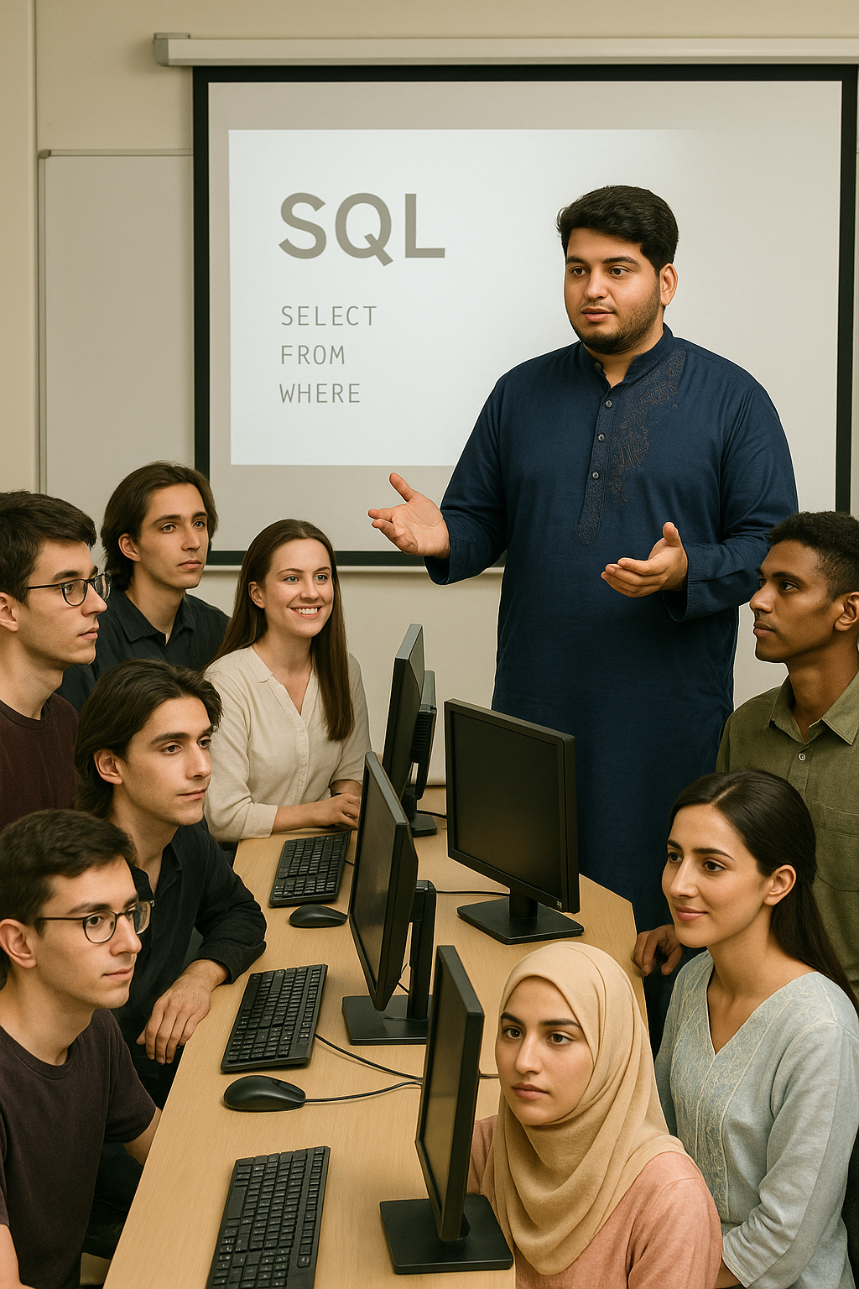
Class of Learners: BCS-4F
I just want to say, you guys have really shown some impressive grit this semester. It’s been fast-paced and challenging, but you kept up, asked great questions, and stayed curious throughout. That kind of attitude shows you’re genuinely interested in learning, and that’s what really matters.
Remember, it’s not just about how much you know or the grades you get-it’s about staying humble, keeping an open mind, and always being willing to learn more. That mindset will take you far, both in school and beyond.
Since the semester is wrapping up, I’ve got a little farewell activity for you. I want you to create a database together and write queries that capture some of your favorite memories from this semester. It’s a fun way to practice what you’ve learned and reflect on the good times we’ve had.
Thanks for all your hard work and for making this class a great place to learn. I’m proud of what you’ve accomplished, and I can’t wait to see where you go from here.

Write the T-SQL statements for the farewell activity
- Write a query to get remarks and student details for your roll number.
- Check the trigger from the provided sql and understand the written query. Describe what you observed in a single line comment
- Create a Table Friends and insert data to friends table
- Create a Trigger on Friends table which prevents having more than 10 friends for each student
- Create a table Lab Remarks having id and text. Add your remarks to the table
- Write a query to list the students who have added remarks and are friends
- List each student with count of his friends having his average grade and average of average grade of his friends
- Write a query to check memories you left with me. (memories table joined with students)
- Write a query to bid farewell to DB Labs i.e. “Select ‘Goodbye Class! We had fun’”

Submission Guidelines

- submit following files strictly following the naming convention: l231234.sql
Best of Luck! Happy Querying

